Exp.No:28
28. Find the boundary of the image using Convolution kernel for the given image.

Aim:
To find the boundary (edges) of an image using a convolution kernel in OpenCV.
Procedure:
- Read the input image (Snake.jpg).
- Convert the image to grayscale.
- Define the boundary detection kernel.
- Apply the kernel using cv2.filter2D().
- Resize the images for medium-size display.
- Display the original and boundary images.
- Save the output image.
Program:
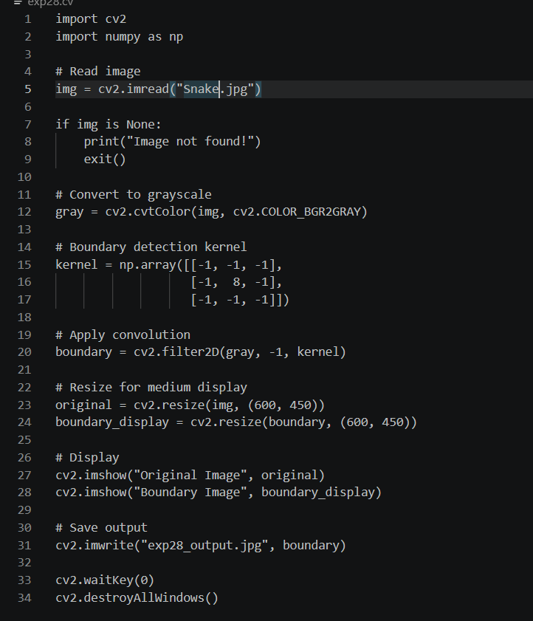
Input:

Output:
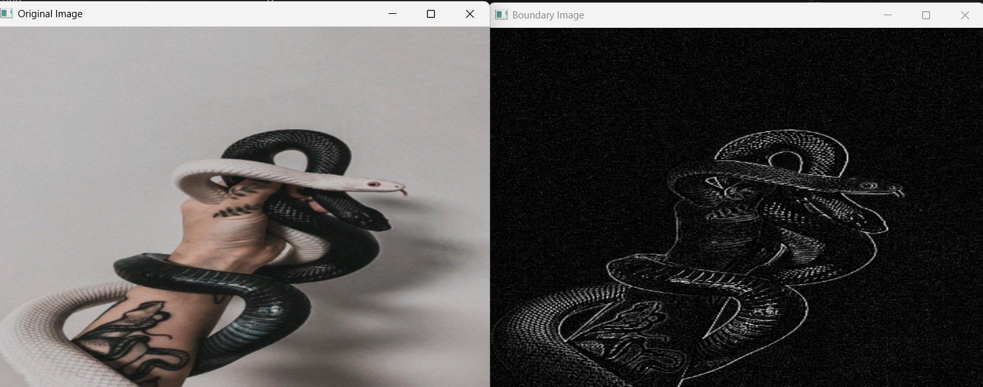

Result:
The boundaries of the input image were successfully detected using a convolution kernel. The boundary image was displayed and saved successfully.

